Step 1
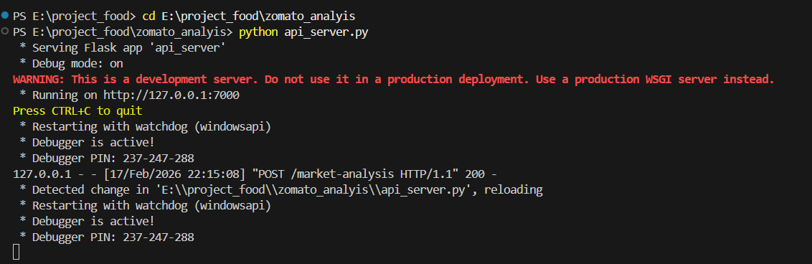
Step 2
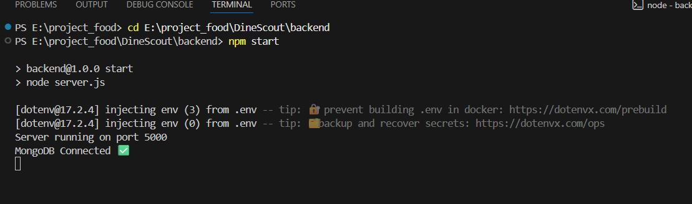
Step3:
click login.html then, click run in vs code.

